**Week2_Junit Basic Testing Exercises**

**SUPESET ID : 6393674**

**Exercise 1: Setting up Junit**

**Calculator.java**

public class Calculator {

public int add(int a, int b) {

return a + b;

}

}

**CalculatorTest.java**

import org.junit.Test;

import static org.junit.Assert.*;

public class CalculatorTest {

@Test

public void testAdd() {

Calculator calc = new Calculator();

int result = calc.add(2, 3);

assertEquals(5, result);

}

}

**OUTPUT:**

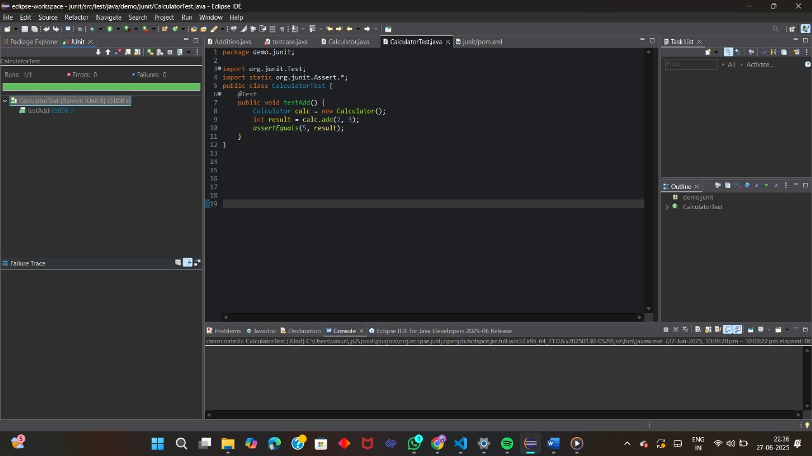

**Exercise 2 : Writing Basic Junit Tests**

**Calculator.java**

package demo.calculator;

public class Calculator {

public int add(int a, int b) {

return a + b;

}

public int subtract(int a, int b) {

return a - b;

}

public boolean isEven(int number) {

return number % 2 == 0;

}

}

**CalculatorTest.java**

package demo.calculator;

import org.junit.Test;

import static org.junit.Assert.*;

public class CalculatorTest {

*@Test*

public void testAdd() {

Calculator calc = new Calculator();

*assertEquals*(7, calc.add(3, 4));

}

*@Test*

public void testSubtract() {

Calculator calc = new Calculator();

*assertEquals*(2, calc.subtract(5, 3));

}

*@Test*

public void testIsEvenTrue() {

Calculator calc = new Calculator();

*assertTrue*(calc.isEven(6));

}

*@Test*

public void testIsEvenFalse() {

Calculator calc = new Calculator();

*assertFalse*(calc.isEven(5));

}

}

**OUTPUT**

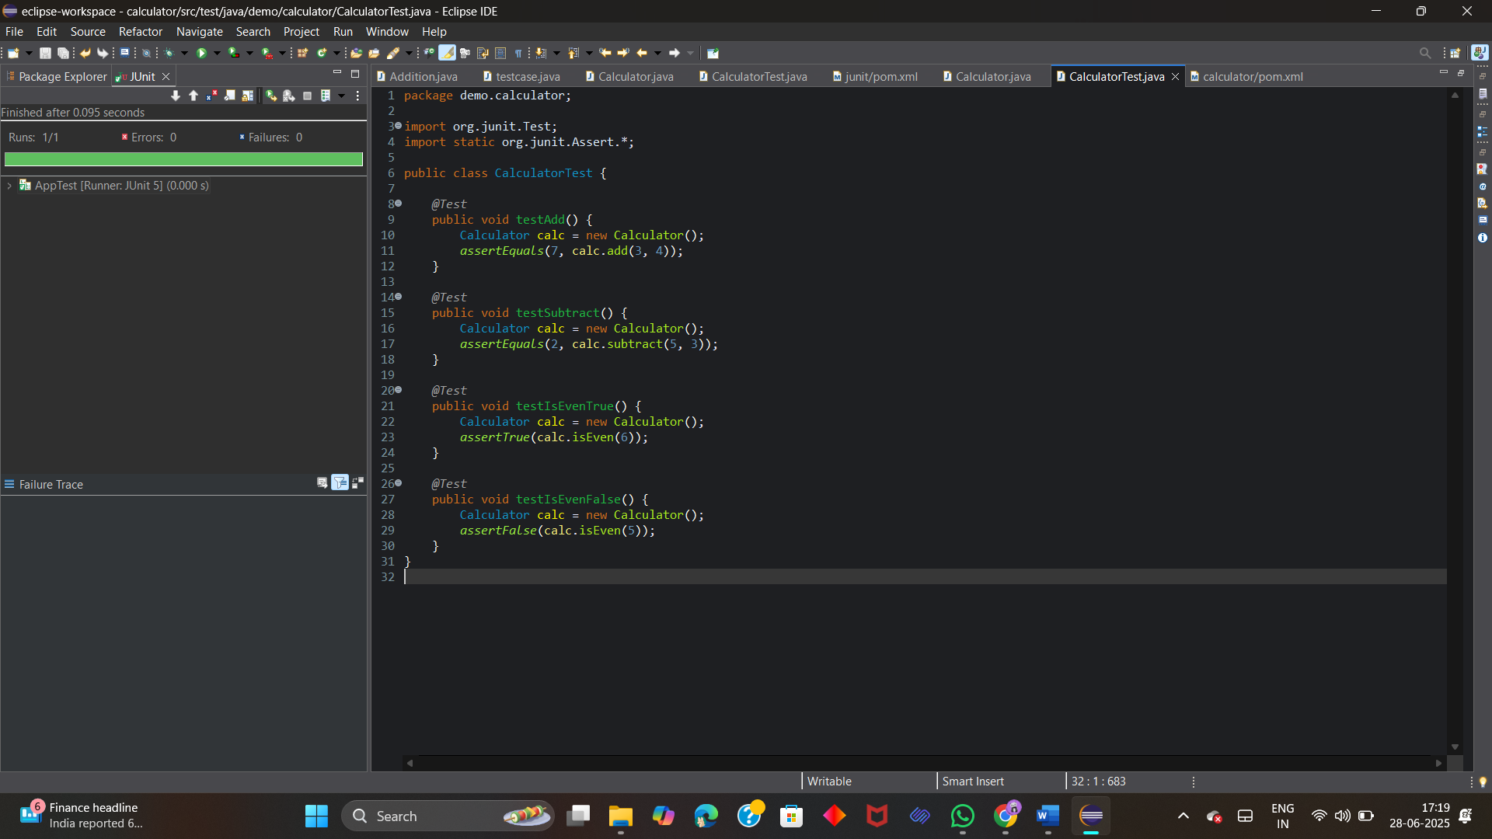

**Exercise 3 : Assertions in Junit**

**AssertionsTest.java**

package demo.Assertions;

import org.junit.jupiter.api.Test;

import static org.junit.jupiter.api.Assertions.*;

public class AssertionsTest {

*@Test*

void testAssertions() {

*assertEquals*(5, 2 + 3);

*assertTrue*(10 > 5);

*assertFalse*(10 < 5);

*assertNull*(null);

*assertNotNull*(new Object());

*assertArrayEquals*(new int[]{1, 2}, new int[]{1, 2});

String a = "abc";

String b = "abc";

*assertSame*(a, b);

*assertNotSame*(new String("x"), new String("x"));

}

}

**OUTPUT:**

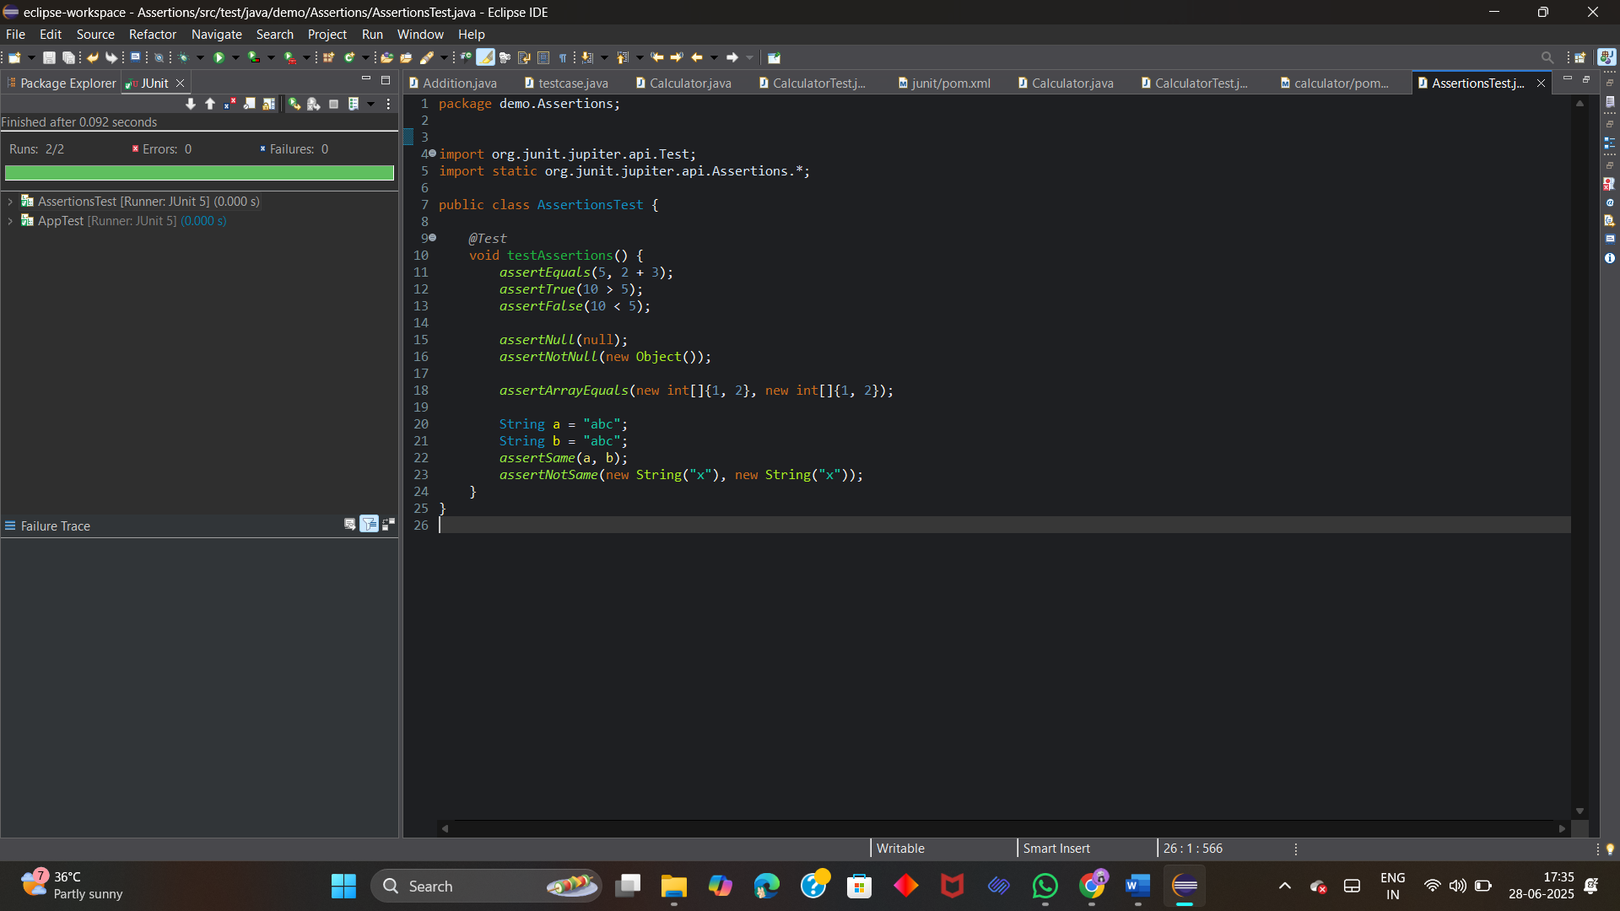

**Exercise 4 : Arrange-Act-Assert (AAA) Pattern, Test Fixtures, Setup and Teardown Methods in Junit**

**Calculator.java**

package demo.AAA;

public class Calculator {

public int add(int a, int b) {

return a + b;

}

public boolean isEven(int num) {

return num % 2 == 0;

}

}

**CalculatorTest.java**

package demo.AAA;

import org.junit.jupiter.api.*;

public class CalculatorTest {

private Calculator calculator;

*@BeforeEach*

public void init() {

calculator = new Calculator();

}

*@AfterEach*

public void cleanUp() {

calculator = null;

}

*@Test*

public void testAdd() {

int result = calculator.add(4, 5);

Assertions.*assertEquals*(9, result);

}

}

**OUTPUT:**

